Room 3 Question 1
Incarcerated Inguinal Hernia
Stem: You are consulted on a A 59-year-old male. He presents with 3 days of abdominal pain, numerous episodes of bilious emesis and a visible, tender right groin mass.
PMH/PSH: with CAD s/p stent x3 in 2015, HTN, HLD, morbid obesity (BMI 43) and a history of a previously reducible right inguinal hernia.
PE : He is tachycardic to 105, otherwise vitals are stable. His abdomen distended, and TTP along the RLQ but non-peritoneal.
Labs: WBC: 11.5k. Otherwise normal.

What is your differential diagnosis?
  - Incarcerated inguinal hernia.
  - Strangulated inguinal hernia.
  - Femoral hernia
  - Adhesive SBO
  - Infected lymph node
  - Orchitis, Testicular torsion
What test / studies do you want?
- CT scan:
- 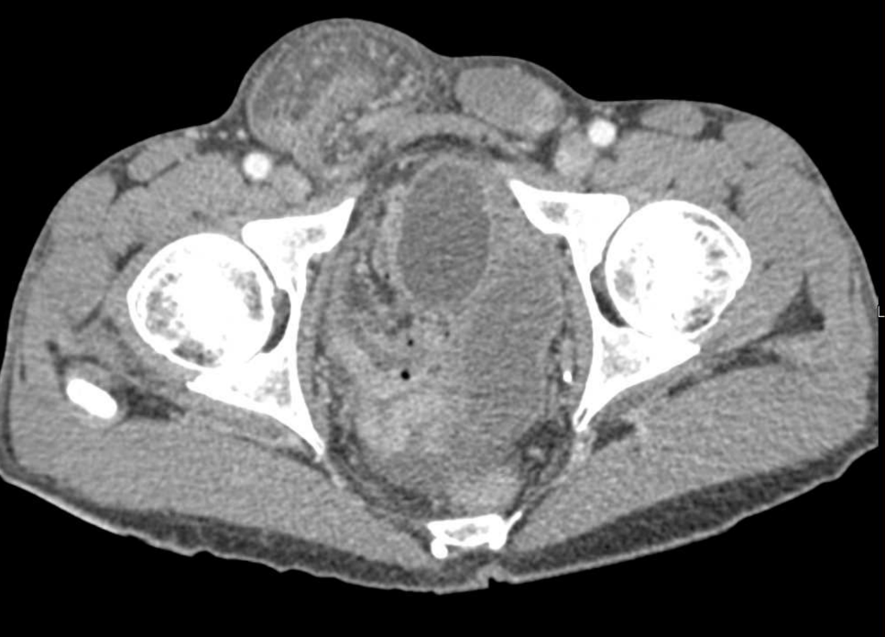
- Right inguinal hernia with bowel loops that appear enhancing and a small amount of free fluid within the hernia sac.
Now what?
- Proceed to the operating room.
What would you consent the patient for and what risks would you describe?
What Approach? (Consent should include chronic pain)
- Inguinal incision.
- Assess bowel.
  - Bowel viable but with inflammation → Reduce, repair, place mesh.
  - Bowel non-perforated but ischemic requiring resection → tissue repair vs. mesh repair are both acceptable
  - Bowel necrotic and perforated → no mesh. Should do tissue repair.
Describe your approach in inguinal hernia repair?
- Lichtenstein:
  - Incision 1 cm above and parallel to the inguinal ligament, beginning from the pubic tubercle and extending 5-6 cm laterally.
  - The Scarpa fascia is similarly opened along the length of the incision, down to the external oblique aponeurosis.
  - The external oblique aponeurosis is then opened along the line of incision, starting from the external ring and extending laterally for up to 5 cm.
  - The superior and inferior flaps of the external oblique aponeurosis are gently freed from the underlying contents of the inguinal canal and overturned and separated to expose the cremaster with the cord structures.
  - identify and isolate the hernia sac.
  - Reduce content.
  - polypropylene mesh is commonly used
  - The first medialmost stitch fixes the mesh 2 cm medial to the pubic tubercle.
  - The same suture is then used as a continuous suture to fix the lower edge of the mesh to the free lower border of inguinal ligament up to a point just lateral to the internal ring.
  - a slit is made in the lateral end of the mesh
  - upper edge is then fixed to the rectus sheath and the internal oblique aponeurosis.
  - The two tails are then tucked together and fixed to the inguinal ligament just lateral to the internal ring, thus creating a new internal ring.
  - Close in layers.
- Can use plug and patch repair.
- Prolene hernia system.

- McVay repair
  - The conjoined (transversus abdominis and internal oblique) tendon is sutured to the Cooper ligament with interrupted nonabsorbable sutures.

- Bassini repair
  - Suturing the transversalis fascia and the conjoined tendon to the inguinal ligament behind the spermatic cord with monofilament nonabsorbable suture.

- Shouldice repair
  - The transversalis fascia is incised from the internal ring laterally to the pubic tubercle medially, and upper and lower flaps are created. These flaps are then overlapped (double-breasted) with two layers of sutures.
  - The conjoined tendon is then sutured to the inguinal ligament, again in two overlapping layers.

Scenario 2: Different patient: 85 year old female who has a palpable, tender mass in the groin. Imaging has not been obtained. What are you concerned about? How would you approach this patient?
Femoral hernia.
- Can you describe McVay/Cooper’s ligament repair?
  - The conjoined (transversus abdominis and internal oblique) tendon is sutured to the Cooper ligament with interrupted nonabsorbable sutures.

Room 3 Question 2

Splenectomy for ITP.
Stem: A 44-year-old female presented to her primary care doctor several months ago complaining of a recent onset of easy bruising and gum bleeding. Workup demonstrated a platelet count <10 × 109/L. She was diagnosed with immune thrombocytopenic purpura (ITP) and admitted to the hospital for treatment.
She was started on high-dose intravenous immunoglobulin and high-dose corticosteroids with an excellent response in her platelet count. She was discharged home on a gradual prednisone taper.
As her prednisone doses were weaned below 20 mg per day, the patient experienced a recurrence in her thrombocytopenia with associated recurrence of easy bruising.

What is your diagnosis and management plan?
- Refractory ITP.
- Bone marrow aspiration: normal marrow cellularity , adequate megakaryocytes. Review of the peripheral blood smear does not demonstrate platelet clumping.
- Splenectomy : After administration of splenectomy vaccines preop.
  - pneumococcal vaccine (PCV13), Haemophilus influenzae type b vaccination (Hib), and meningococca
Patient came to you because you perform minimal invasive procedures , How would you perform her surgery? (Resident to describe one minimal invasive approach, Patients with ITP are ideal candidates for a minimally invasive approach because they are frequently young, otherwise healthy patients with normal-sized spleens.)
- Laparoscopic: Describe?
  - Patient positioned in modified right lateral decubitus position.
  - Abdominal access
  - Ports are placed as :
    - 12-mm trocar ~3–4 cm below the left costal margin in the midclavicular line.
    - Two 5-mm trocars are placed along the costal margin between xiphoid process and 12 mm trocar.
  - Divide the splenocolic ligament and mobilize the splenic flexure caudad.
  - Additional 12-mm trocar is placed in the left anterior axillary line below the costal margin.
  - The short gastric vessels are divided in their entirety up to the level of the superior pole of the spleen.
  - Mobilize inferior pole of the spleen by dividing splenorenal ligament.
  - Mobilize the superior pole of the spleen to isolate the splenic hilum.
  - The splenic hilar vessels are divided with an endoscopic stapler.
  - Spleen is placed in endobag, which is exteriorized through the Hasson trocar site so the spleen can be morcellated.
  - Upon completion, the abdomen is then reinspected laparoscopically to ensure hemostasis.

- Hand Assisted laparoscopic Splenectomy.
  - Patient is positioned in modified right lateral decubitus position.
  - Abdominal access
  - Ports are placed as :
    - 12-mm trocar ~3–4 cm below the left costal margin in the midclavicular line.
    - Two 5-mm trocars are placed along the costal margin between xiphoid process and 12 mm trocar.
  - Divide the splenocolic ligament and mobilize the splenic flexure caudad.
  - Additional 12-mm trocar is placed in the left anterior axillary line below the costal margin.
  - The short gastric vessels are divided in their entirety up to the level of the superior pole of the spleen.
  - Connect the 5-mm skin incisions and open the subcutaneous tissue and fascia.
  - Place hand port. Utilize left hand to protect and retract the spleen and the right hand to use dissecting instruments.
  - Mobilize inferior pole of the spleen by dividing splenorenal ligament.
  - Mobilize the superior pole of the spleen to isolate the splenic hilum.
  - The splenic hilar vessels are divided with an endoscopic stapler.
  - Spleen placed in large endobag or sterile x-ray cassette cover and exteriorized through the hand-port site, so the spleen can be morcellated or removed in its entirety.

Room 3 Question 3

Melanoma
Stem: A 40-year-old male presents with a pigmented lesion on his right lower extremity. First noticed it three months ago, denies recent changes in the appearance of the lesion. He uses sunscreen sporadically and recalls having sunburns as a teenager.
His medical and surgical history are unremarkable.
He denies a personal or family history of skin cancers.
Physical exam reveals this

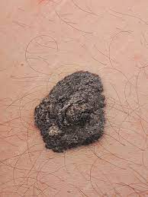

What is your differential diagnosis?
- Melanoma
- Melanocytic nevus
- Basal cell carcinoma
- Seborrhoeic keratosis
- Dermatofibroma

What would you like to do now?
- Complete skin exam evaluating for additional suspicious lesions, regional lymph node exam.
- Biopsy

Biopsy returns as melanoma, Breslow depth 1.2mm with no evidence of ulceration, mitotic rate < 1 mitosis/mm² (T2a)

What is Next?
Wide local excision and SLNB w/ margins of 1.0 to 2.0mm
Order immunohistochemistry for nodes (BRAF, S100)

Pathology returns as residual melanoma, Breslow depth 1.2mm, negative margins, 2 of 3 nodes positive for metastatic disease.
- Stage w/ PET CT
- Completion lymph node dissection VS active nodal surveillance w/ ultrasound.

What’s the risks and benefits of both?
- Lymphedema in CLND (24%) vs surveillance (6%)

Patient elects CLND, What’s now?
Inguinal lymph node dissection:
- Mark Incision
- Dissect the subcutaneous until you reach superficial fascia (Campers fascia).
- Incise the fascia gently.
- Lift the fascia and dissect parallel to the lower border of the fascia to separate the superficial inguinal nodes from the subcutaneous tissue.
- Continue until you reach the inguinal ligament (upper border of the dissection).
- Dissect the superficial inguinal lymph nodes off the inguinal ligament starting from the upper edge of the ligament down to the femoral triangle.
- Dissect the lymph-nodes off the muscles.
- Separating the groin nodes off the femoral triangle floor proceeding from lateral to medial.
- Identify the great saphenous vein and dissect carefully until the point of insertion with the femoral vein.

- Adjuvant therapy options: nivolumab (programmed death 1 inhibitor)

- Or targeted therapy with combination of BRAF/MEK inhibitors;
(IFN alfa and ipilimumab have fallen out of favor)

- Follow up every 3-6 months for 2-3 years, then annually.

Scenario: Another patient, referred by dermatologist for punch biopsy with Breslow depth of 0.7mm, no ulceration

1. Wide local excision with 1.0mm margins, no SLNB

Scenario: Same patient but has a firm, palpable lymph node in the right groin?! Now what?!

FNA : Metastatic melanoma (should not recommend excisional biopsy as it may interfere with future node dissection.

How would you manage metastatic Melanoma?!

- Test tumor for BRAF gene mutation

- Stage w/ CT c/a/p or PET CT +/- MRI brain:
(Regional disease appears borderline resectable.)

- Refer to medical oncologist for systemic therapy

Can you give examples?!

Nivolumab (anti-PD-1 antibody), targeted therapy against BRAF (dabrafenib) or downstream target MEK (trametinib)

